Chemical Tests For Biologically Important Molecules

Introduction

The most common and important organic molecules found in living things fall into four classes:
carbohydrates, lipids, proteins, and nucleic acids. Each class of molecules have different characteristics based on the combination of nitrogen, carbon, oxygen, and hydrogen used, as well as the actual structure and shape of the molecule.

Each of these classes of organic molecules has a chemical test to indicate whether or not it is present in a solution. This is useful in identifying the types of compounds that make up a living organism or a product of a living organism.

Purpose

The purpose of this lab is to familiarize the student with a series of biochemical tests used to identify presence of specific types of organic molecules.

Procedure 1: Benedict’s Test for Reducing Sugars

Background:

Carbohydrates are made of monosaccharides, or simple sugars. There are three types of monosaccharides you will work with, each a major source of energy for organisms at the cellular level: glucose, fructose, and galactose.
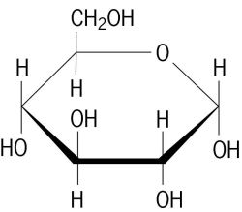 | 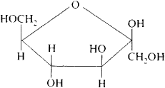 | 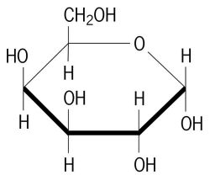
Glucose | Fructose | Galactose

Benedict’s test gives a color change when reducing sugars (or monosaccharides) are present. Most complex sugars, such as disaccharides (made from two linked monosaccharides) and polysaccharides (made from three or more linked sugars) react poorly with Benedict’s solution.

Materials:
- Seven test tubes  - Test tube rack  - Hot plate  - 400mL beaker  - Test tube holder  - Benedict’s solution  - Plastic pipette | - Onion juice  - Potato juice  - Sucrose solution  - Glucose solution  - Distilled water  - Starch solution

Procedure
- Fill up a beaker about halfway with water and place it on the hot plate. Heat the water to boiling.

- Number each of the test tubes 1-7.
- Add 10mL of the following materials to be tested to each test tube:
  - Distilled water
Rinse the graduated cylinder after measuring each solution to prevent contamination!

  - Reducing-sugar solution
  - Glucose solution
  - Sucrose solution
  - Starch solution
  - Onion solution
  - Potato solution

- Add 5 drops of Benedict’s solution to each test tube using a plastic pipette.

- Make a prediction of how each material will react. Write a plus sign (+) for a positive test and a negative sign (–) for a negative test.

Table 1: Predicted Results of Benedict’s Test
Distilled water | Reducing sugar | Glucose | Sucrose | Starch | Onion | Potato

A negative control does not contain the variable you are testing for. Negative controls should always test as negative. A positive control contains the variable and should always test as positive.

- Which of the solutions would be a negative control?

- Which of the solutions would be a positive control?

- Why is it important to have a control with a test like this?

- Place each of the test tubes into the gently boiling beaker of water.

- Allow 3 minutes for the reaction to complete. Observe any color changes in the test tubes.

- Record your results below:

Table 2: Actual Results of Benedict’s Test
 | Distilled water | Reducing sugar | Glucose | Sucrose | Starch | Onion | Potato
Test Result
Observed Color

- Which tested most strongly positive: glucose, sucrose, or starch? Does this make sense?

- Were any of your original predictions incorrect? Which one(s)?
Procedure 2: Iodine Test for Starches

Background:

Starch is a polysaccharide, made of hundreds of repeating glucose molecules linked together. It is the main molecule of carbohydrate energy storage used by plants.
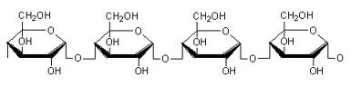
A small segment of a starch molecule

The coiled shape that the starch molecule takes allows it to react with iodine, forming a bluish black color.

Materials:
- Seven test tubes  - Test tube rack  - Iodine (I₂KI) solution  - Onion juice  - Potato juice | - Sucrose solution  - Glucose solution  - Distilled water  - Starch solution
Procedure

- Number each of the test tubes 1-7.

- Add 10mL of the following materials individually to each test tube:
  - Distilled water
  - Reducing-sugar solution
  - Glucose
  - Sucrose solution
  - Starch solution.
  - Onion solution
  - Potato solution

- Make a prediction of how each material will react. Write a plus sign (+) for a positive test and a negative sign (–) for a negative test.

Table 3: Predicted Results of Iodine Test
Distilled water | Reducing sugar | Glucose | Sucrose | Starch | Onion | Potato

- Which of the solutions would be a negative control?

- Which of the solutions would be a positive control?

- Add 7-10 drops of iodine solution to each test tube. Observe and record the results.

Table 4: Actual Results of Iodine Test
 | Distilled water | Reducing sugar | Glucose | Sucrose | Starch | Onion | Potato
Test Result
Observed color

- Which is a polysaccharide: starch, glucose, or sucrose?

- What has a higher amount of starch: potato, or onion?

- Based on the iodine and Benedict’s tests, compare how potatoes and onions store energy differently.

Procedure 3: Sudan IV Test for Lipids

Background:

Lipids are biological molecules made from three fatty acids bonded to a molecule of glycerol. Unlike carbohydrates, lipids are nonpolar and do not dissolve well in polar solvents such as water. Lipids only dissolve in nonpolar solvents.

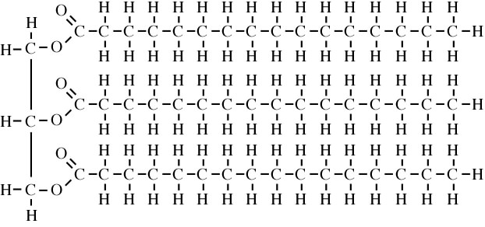
Glycerol Three Fatty Acids

Due to this property of lipids, an effective test for them is to add a nonpolar dye. This dye can be easily absorbed by nonpolar substances such as lipids, while nonpolar substances are unable to dissolve it.

Materials:
- Five test tubes  - Test tube rack  - Sudan IV solution  - Distilled water  - Lipid solution | - Honey  - Salad oil
Procedure
- Number each of the test tubes 1-4.

- Combine 1 mL of salad oil with 1mL of distilled water in the first test tube.

  - Is salad oil soluble in water?

  - Based on this, is salad oil polar or nonpolar?

- Add one mL of each of the following to test tubes 2-5:
  - Distilled water
  - Lipid solution
  - Honey
  - Vegetable oil

- Predict the results of the Sudan IV test.

Table 5: Predicted Results of Sudan IV Test
Distilled Water | Lipid Solution | Honey | Vegetable Oil

- What kind of reaction or change do you expect with a positive test?

  - Which of these solutions would be the negative control?

  - Which of these solutions would be the positive control?

- Add a small amount (enough to fit on the end of a toothpick) of Sudan IV to each test tube.

- Mix the contents of the test tube by lightly tapping it against your hand.

- Record the results.

Table 6: Actual Results of Sudan IV Test
Distilled Water | Lipid Solution | Honey | Vegetable Oil

- How does the dye react differently with positive versus negative results?

- Would you consider honey to be a food high in lipids? Salad oil?

- Lipids supply about 9 calories per gram, while carbohydrates supply about 4 calories per gram. Given your results, what would you expect to have more calories, a tablespoon of honey, or a tablespoon of salad oil?

Procedure 4: Grease-Spot Test for Lipids

Materials
- Square pieces of brown paper (one for each substance to be tested)
- Food samples
- Dropper or pipette

Procedure
- Use a pipette or dropper to add a drop of salad oil to one of the squares of brown paper

- Take a separate piece of paper and add a drop of distilled water.

- Hold each paper up to the light.

- Based on your observations, what would a positive test result look like?

- Repeat the test for each of the food samples provided. Record your results below:

Table 7: Grease-spot Test Results
Distilled Water | Honey | Vegetable Oil | Onion Solution | Potato Solution

Procedure 5: Biuret Test for Proteins

Background:

Proteins, also known as polypeptides, are large organic molecules made of amino acids. Each amino acid molecule contains a amino group (-NH2), a carboxyl group (-COOH), and another group that can vary and is referred to as (-R).
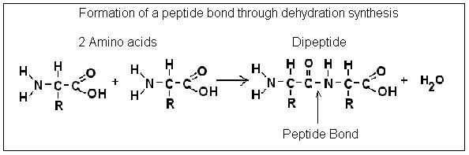
The bonds between carbon and nitrogen (called peptide bonds) react with Biuret reagent to produce a violet color. Biuret only reacts positively with peptides, not with individual amino acids.

Materials
- Five test tubes  - Egg white  - Honey  - Potato solution | - Amino Acid solution  - Distilled water  - Protein solution  - Onion solution
Procedure
- Number the test tubes 1-5.

- Add 5mL of the following materials individually to each test tube:
  - Egg white
  - Honey
  - Amino acid solution
  - Distilled water
  - Protein solution
- Predict the results of the biuret test.

Table 8: Predicted Results of Biuret Test
Distilled water | Protein Solution | Amino Acid Solution | Egg White | Honey | Potato | Onion

- Which of these solutions would be a positive control?

- Which of these solutions would be a negative control?
.
- Add three drops of Biuret reagent to each tube and mix gently.
- Record the results of the Biuret test.

Table 9: Actual Results of Biuret Test
 | Distilled water | Protein Solution | Amino Acid Solution | Egg White | Honey | Potato | Onion
Result
Observed Color

- Based on your results, what had a higher amount of protein, egg white or honey?

- In general, would you expect to find higher amounts of protein in plant-based foods or animal-based foods?

Procedure 6: Dische Diphenylamine Test for DNA
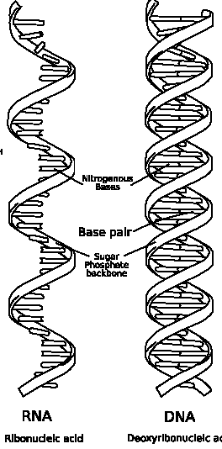
Background:

There are two types of nucleic acids found in living organisms: DNA, and RNA. The main difference between these two molecules is that DNA contains a sugar called deoxyribose, while RNA contains ribose.

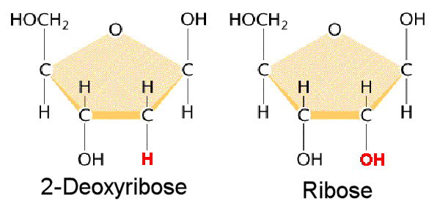

The deoxyribose in DNA reacts with diphenylamine, producing a blue color.

Materials:
- Four test tubes  - Dische diphenylamine reagent  - Distilled water | - DNA Solution  - RNA Solution
Procedure:
- Number the test tubes 1-4.

- Add the following materials individually to each test tube:
  - 2mL distilled water
  - 2mL DNA solution
  - 1mL DNA solution + 1mL distilled water
  - 2mL RNA (if available)

- Add 2mL of Dische Diphenylamine to each test tube.
  - Perform this step in a ventilated fume hood!

- Boil in a water bath for 10 minutes.
  - Perform this step in a ventilated fume hood!

- Record the results of the Dische diphenylamine test.

Table 10: Results of Dische diphenylamine test
 | Distilled water | DNA Solution | DNA +  Distilled Water | RNA
Results
Observed Color

