Biochemical Compounds
Functional Groups
Methyl Group | One carbon molecule attached to three hydrogen molecules and another molecule. | R-C-H₃
Hydroxyl Group | A molecule with an oxygen and hydrogen attached | R-O-H
Carboxyl Group | A carbon molecule attached to both a hydroxyl group and a double bonded oxygen | R-C=O  |  O-H
Amino Group | A molecule bonded to a nitrogen atom. | R-N-H₂
Carbonyl Group | A carbon double bonded to an oxygen molecule. Can be one the first carbon (aldehyde) or within the molecule (ketone) | R-C=O aldehyde  |  H  R-C=O ketone  |  R

Reactions
Dehydration or Condensation- water is removed (H₂O)
Hydrolysis- reaction where water is added.

Building Biochemical Molecules
Carbohydrates
The general formula for carbohydrate is C_{n}(H₂O)_{n}.
- Build the simplest carbohydrate.
- The formula is C_H_O_, which is known as formeldahyde.
- The fuctional group is _______________.
- Build a carbohydrate containing 2 carbon molecules.
- The formula is C_H_O_, which is known as glyceraldehyde.
- There are two functional groups present, they are __________________ and _________________
- Make a straight chain molecule of glucose, the chemical formula is C₆H₁₂O₆.
- What do you notice about this molecules arrangement?

- Form a ring, using your straight chain of glucose. The oxygen atom will bond to the 5th carbon in the chain.
- How do we number the carbons in a molecule?

Glucose in a monomer or monosaccharide. Two glucose molecules can bind together, through a dehydration reaction, to form a disaccharide, known as maltose. When three or more monomers of glucose bind together, they form a polysaccharide.
- Form a di- or poly- saccharide with a group around you. What bi-product was formed?

Proteins
Proteins are formed by two or more amino acids bound together by a peptide bond. The basic structure of an amino acid is:
H  |  H₂- N- C- C = O  | |  R O-H | What are the two functional groups present in an amino acid?

- Looking at the chart on the next page build both Glycine and Alanine.
- Your Glycine and Alanine undergo a dehydration reaction, build what the resulting protein. The bond that is formed between the molecules in known as a peptide bond.
- Build a Serine molecule
- Add this Serine molecule to your peptide chain.
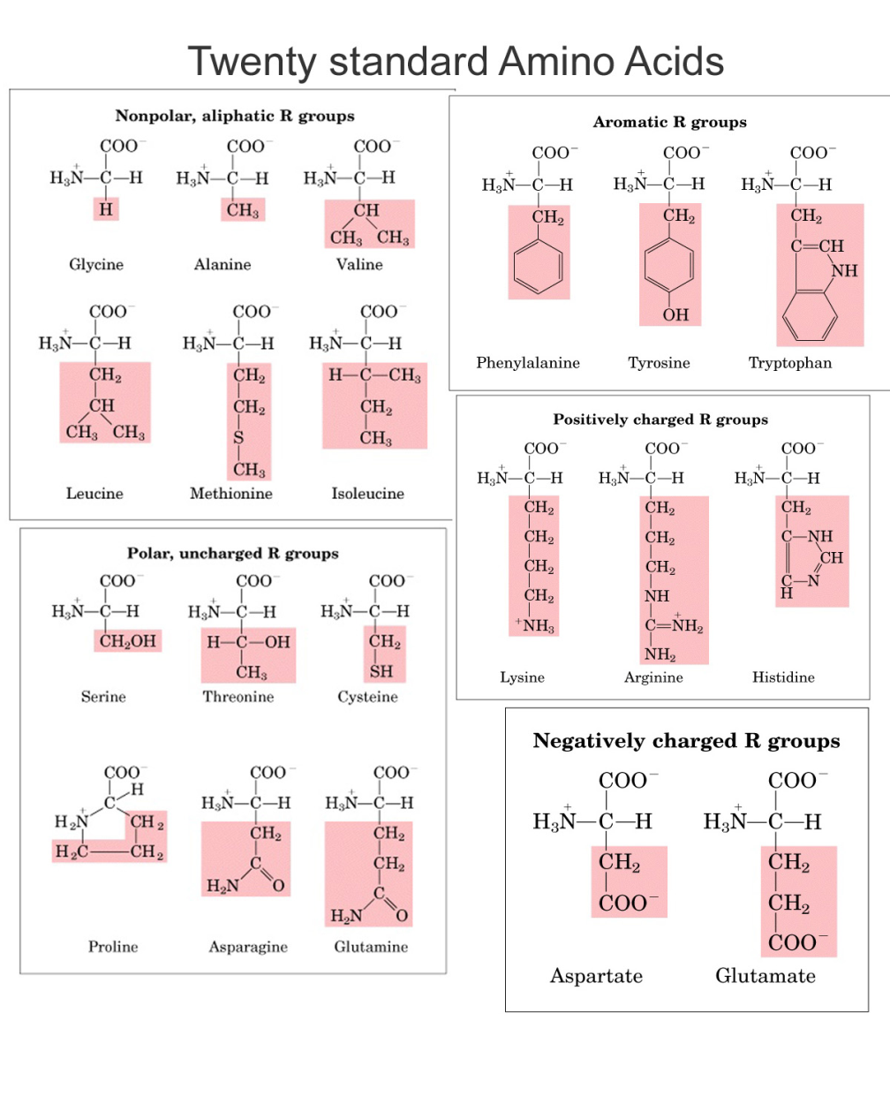
Lipids
One type of lipid, known as a triglyceride, consists of one glycerol molecule and three fatty acid chains.
- Build a glycerol molecule, formula is C₃H₈O₃ each carbon has a hydroxyl group attached.
- Build three fatty acid chains, consisting of at least two carbons each. A fatty acid chain has one carboxyl group on the first carbon.
- These fatty acid chains can be dehydrogenated, forming double bonds between two carbon atoms. Add a double bond between two carbon atoms in one of your fatty acid chains.
- Build a triglyceride. The glycerol and fatty acid chains undergo three separate ______________ reactions, to form a triglyceride and three water molecules.
- Add two more double bonds in your fatty acid chains of your triglyceride. When fatty acids contain double bnds they are said to be unsaturated fats. When there are no double bonds then the fat in saturated.
- As you add in double bonds in the fatty acid chain what happens to the arrangement of the molecule?

