Adapted from: http://www.biologycorner.com/worksheets/stomata.html
Name(s) _______________________________

Investigation of Leaf Stomata
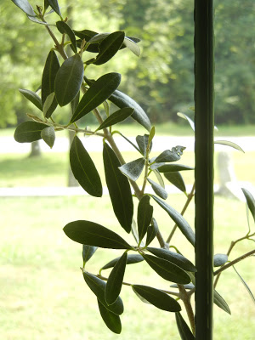

Materials:
- Plant leaves
- Clear fingernail polish
- Clear tape
- Microscope
- Microscope slides

Procedure:
- Obtain a leaf from a plant; generally any plant will work for this procedure.
- Paint a thick patch of clear nail polish on the leaf surface being studied (try the top of the leaf and bottom of the leaf to examine the differences). Make your patch at least one square centimeter.
- Allow the nail polish to dry completely.
- Tape a piece of clear cellophane tape to the dried nail polish patch. (The tape must be clear. Do not use Scotch tape or any other opaque tape. Clear carton-sealing tape works well.)
- Gently peel the nail polish patch from the leaf by pulling on a corner of the tape and peeling the fingernail polish and epidermal layer off the leaf. This is the leaf impression you will examine.
- Tape your peeled impressions to very clean microscope slides. One slide will have the impression from the top of the leaf, and the other slide will have the impression from the bottom of the leaf. Use scissors to trim away any excess tape.

Investigate:
Scan the slide until you find a good area where you can see the stomata. Each stoma is bordered by two sausage-shaped cells that are usually smaller than the surrounding epidermal cells. These small cells are called guard cells and unlike other cells in the epidermis, contain chloroplasts.
1. What was the difference between the impressions taken from the top of the leaf, and the bottom of the leaf? Sketch the impression where the stomata were visible. Label the Stoma, Guard Cells, Epidermal Cells, and Chloroplasts.

2. Estimate the number of stomata on your sample.

*You will need to obtain a plant kept in the dark for the next part of the lab.*

Experiment:
Guard cells are responsible for opening and closing the stoma. When water concentration is high, the guard cells will bulge, and cause the stoma to open. When the water concentration is low, the stoma will close. Stomas are generally open when plants are photosynthesizing.
Question: Will plants have more stoma open during the day than during the night?
3. Develop a hypothesis about the number of open stomata found in a plant kept in the dark compared to a plant in the light. Write your hypothesis below, and make sure that it is a complete sentence.

Repeat the procedure above for preparing your slide (this time, only use the side of the leaf where the stomata were visible). You will make two impressions, one from a "Dark Plant" and one from a "Light Plant" You will compare the two impressions.
4. Data Table:
Plant | Number of Stomata
Light
Dark

5. Conclusions: Write a short paragraph that answers the question; use your data to support your conclusions.

