Station 1 – Colour Blind Test
This station is to be completed by taking an online test that will assess each individuals level of colour blindness. It can be done by the group, all at once, by vising the following site:
http://www.colour-blindness.com/colour-blindness-tests/ishihara-colour-test-plates/
Follow the instructions and be sure to record your results for each circle!
You may want to construct a chart like this to record your results:
Test plate # | My Answer | Non-colour blind answer | Meaning

Station 2 – Words and Numbers
This station is to be performed in partners. Each partner will take turns performing the two tests below, while the other partner keeps track of time. If a timer cannot be provided, use the clock inside the classroom. Remember there are two tests to perform. This is not a competition, just keep track of your time for your own information!
Test 1 – Is that English?
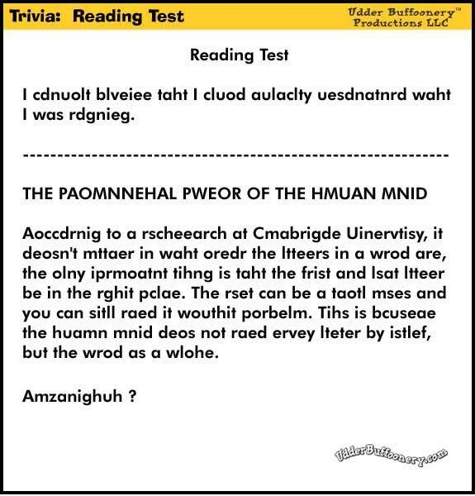
Test 2 – Find the difference!
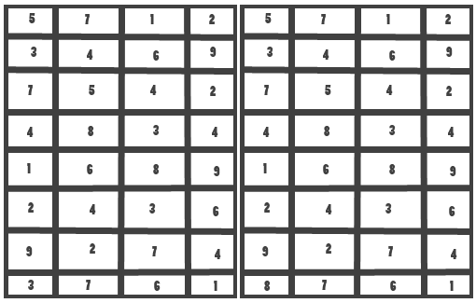
Station 3 – Optical Illusions
View the images below, record your observations. You may want to construct a chart like this to record your results:
Image Number | First Image | Second Image | Which I saw first
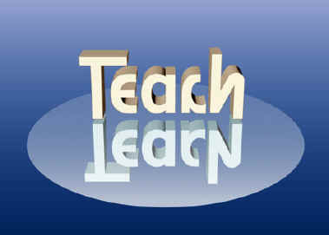
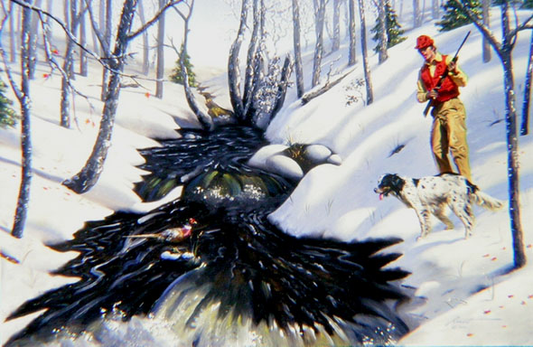
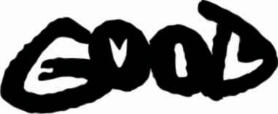

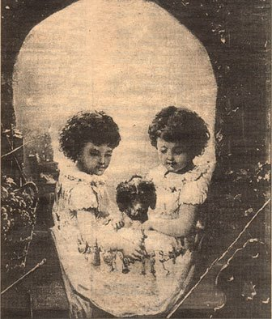

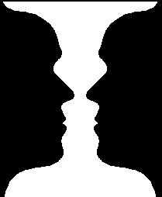

Station 4 – Astigmatism Test / How good is your vision?
Follow the steps for each image below:
- Stand ~3 meters from the page
- Cover one eye at a time
- Observe the lines
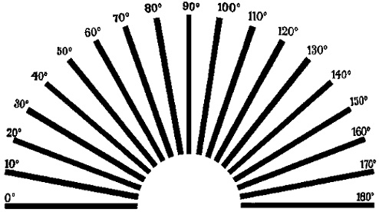

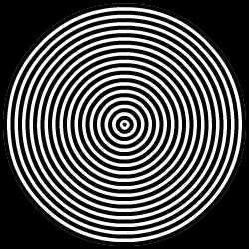

All images are composed of black lines, but if you see some grey, colour, or if some lines are blurry / lighter than others, you may have astigmatism!
Station 5 – After Images
Use the Red and Black construction paper provided.
Starting with the red squares, stare at the square for 30 seconds and then immediately look at a white image (wall, blank piece of paper etc.). What did you see?

Try the same with the black construction circles. Did you see the same thing?

Try using something other than the paper provided, while using the same approach.

