Fill In The Blank
- Synthetic hormones in ____________ trick the ovary into thinking it has already released an egg (birth control pills)
- The main function of estrogen is to thicken the ____________of the uterus (lining)
- If ____________ does not happen, the endometrium sheds (conception)
- During ovulation, ____________ levels increase while ____________ levels decrease (LH, estradiol)
- The follicular phase can last for about ____________ days or until ____________ happens (10-13, ovulation)
- Even though a female may be using birth control, the ____________ still builds and is released, this is the withdrawal period (endometrium)
- Appearance of the corpus luteum happens during the ____________ phase (luteal)
- If ____________ and ____________ are prevented from releasing, follicles cannot grow (FSH, LH)
- Some women who take the pill can still ____________; the pill does not completely stop GnRH (ovulate)
- LH is responsible for causing the ____________ of an egg (release)

True/False Questions

- It is not possible for a woman to identify the fertile window of the menstrual cycle. True / False (false)
- It is not possible to get pregnant on every day of a women’s cycle. True / False (true)
- A woman is likely to get pregnant on the days right before her period. True / False (false)
- A woman is likely to get pregnant on the days right after menstruation (her period). True / False (false)
Multiple Choice Questions

- What is the result of decreasing progesterone and estrogen levels? (B)
- A) Production of FSH and LH
- B) Fertilization of the egg
- C) Shedding of the endometrium
- D) Another unit test from your teacher
- Which hormone is the Corpus Luteum responsible for producing? (A)
- A) Progesterone
- B) Follicle Stimulating Hormone
- C) Luteinizing hormone
- D) Gonadotropin-releasing hormone

- If ovulation were considered to be the point in the menstrual cycle where women are most fertile, at which point would this occur in? (B)
- A) Days 1-5
- B) Days 9-16
- C) Days 17-21
- D) Days 22-28
- At which stage of the menstrual cycle does the follicular phase occur? (D)
- A) Days 12-16
- B) Days 16-28
- C) Days 20-28
- D) Days 1-13

- Approximately how long does the menstrual cycle occur? (A)
- A) 28 days
- B) 27 days
- C) 12 days
- D) 5 days

- Where are Luteinizing hormone (LH) and Follicle Stimulating hormone (FSH) produced? (D)
- A) Adrenal glands
- B) Hypothalamus
- C) Posterior pituitary
- D) Anterior pituitary

- Where is Gonadotropin-releasing hormone produced? (A)
- A) Hypothalamus
- B) Hippocampus
- C) Hippopotamus
- D) Hippolyta

- Growth and thickening of the endometrial lining is caused by (A)
- A) Rising estrogen and progesterone levels
- B) Rising estrogen and testosterone levels
- C) Rising LH and FSH levels
- D) Decreasing estrogen and progesterone levels
- Name the hormones used in a typical birth control pill that essentially prevent the release of an egg (B)
- A) Testosterone and progesterone
- B) Progestin and estrogen
- C) Estrogen and oestrogen
- D) Estrogen and progesterone
- What happens when there is a surge of LH? (A)
- A) Ovulation
- B) Shedding of the endometrium
- C) Conception
- D) Inception

- High concentrations of estradiol causing the stimulation of GnRH is an example of (A)
- A) Positive feedback
- B) Negative feedback
- C) Cascading
- D) Secretion
- The hormones of the birth control pill decrease the release of (B)
- A) Progestin
- B) GnRH
- C) FSH and Progestin
- D) Estrogen and GnRH

- What does the dominant follicle become after it has released an egg? (A)
- A) Corpus luteum
- B) Endometrium
- C) Embryo
- D) Pituitary gland
- A spike in LH is an indication of (D)
- A) A growing follicle
- B) Formation of the corpus luteum
- C) Formation of the corpus albicans
- D) None of the above
- What can cause negative feedback to occur (C)
- A) Low concentrations of estradiol inhibiting the release of FSH
- B) Low concentrations of progesterone and estradiol inhibiting the release of GnRH
- C) A and B
- D) None of the above

Short Answer Questions

- Describe briefly the changes that would be taking place in the uterus between days 1 – 13 of the menstrual cycle (regrowth and thickening of endometrium/uterine lining)
- State ONE day of the cycle on which sexual intercourse could lead to pregnancy. Give ONE reason for you answer (any day that is put down between days 10 – 17; reason is just before or just after ovulation)
- Figure 1 is a graph showing the hormones involved for an individual with a regular 28 day menstrual cycle:
Figure 1.
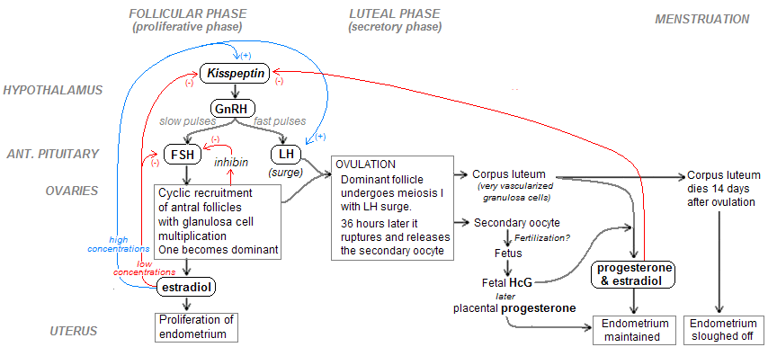
Write down the names of the hormones in the appropriate box
- Figure 2 is a graph showing the hormones involved and their levels for an individual with a regular 28 day menstrual cycle:
Figure 2.
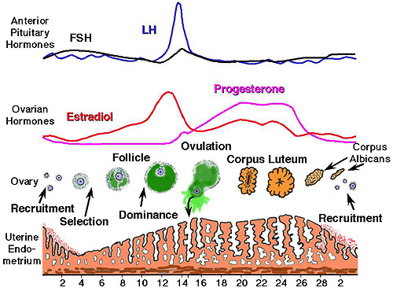
Write down the names of the hormones in the appropriate box.

- Figure 3 is a graph showing the concentration of two sex hormones in the blood of an individual with a regular 28 day menstrual cycle:
Figure 3.
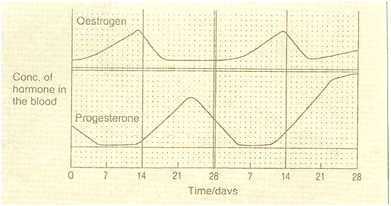

Shade two periods on the graph during which menstruation really takes place and name the phase (only ONE phase) (Days 1-5 and 28 – 5; follicular phase)

